

AIN SHAMS UNIVERSITY
FACULTY OF ENGINEERING
Ahmed Mohamed Abdelkader
DEPARTMENT

Design of power management control strategy for reducing fuel consumption in a single seated electric hybrid vehicle

A Thesis submitted to the
Faculty of Engineering at Ain Shams University
in partial of the fulfillment of the requirements of the degree of
Master of Science In Mechanical Engineering

By
Eng. Ahmed Mohamed Abdelkader

Supervised by
Professor/ Nabila Shawky Elnahas
Dr/Mohamed Ahmed Abdelaziz

Statement

This thesis is submitted as a partial fulfillment of Master of Science in Mechanical Engineering (Automotive Engineering), Faculty of Engineering, Ain Shams University.
The author carried out the work included in this thesis, and no part of it has been submitted for a degree or a qualification at any other scientific entity.

Student name
Ahmed Mohamed Abdelkader
Signature
……………………………………………..
Date: July 21st 2016

  - Researcher Data

Name : Ahmed Mohamed Abdelkader
Date of birth : 29/07/1985
Place of birth : Cairo, Egypt
Last academic degree : B.Sc. in Mechanical Engineering
Field of specialization : Automotive Engineering
University issued the degree: Ain Shams University
Date of issued degree : 2008
Current job : Demonstrator

ACKNOWLEDGMENT

First of all, I thank Allah for giving me strength and ability to complete this study.
I would like to express my sincere appreciation to Dr Nabila Elnahas for her endless support, advices and encouragement that pushed me to do my best in order to fit for her generous trust.
I would like also to express my deepest gratitude to Dr Mohamed Abdelaziz for his close supervision, and generous guidance throughout the whole work that facilitated the completion of this study, in addition to his endless support.
I would like to express my thankfulness to all of the professors who have taught and mentored me. Thanks also go to my colleagues in the automotive Department, for their encouragement and support.
Last but not least I express my gratitude to my loving and encouraging family for their continuous motivation, endless support, and patience.

ABSTRACT
The intent of this study is the design, modeling, simulation and testing of power management control strategy for increasing fuel efficiency over regulated driving cycles for a single seated post transmission parallel hybrid electric vehicle. A post transmission parallel hybrid power train has been studied, with the electric motive power coming after the transmission, utilizing a belt driven coupling.
A control strategy has been developed for the operation of the powertrain, Simulink models of the power train were built to obtain the results, which were validated against experimental data obtained from test carried out on a single seat HEV. The result shows that fuel consumption as well as the exhaust gas emissions of the hybrid vehicles are less than that of the comparable conventional vehicles.

TABLE OF CONTENTS
Supervised by Professor/ Nabila Shawky Elnahas Dr/Mohamed Ahmed Abdelaziz i
Statement ii
Researcher Data i
ACKNOWLEDGMENT i
ABSTRACT ii
TABLE OF CONTENTS iii
LIST OF FIGURES vii
LIST OF TABLES x
NOMENCLATURE xi
CH1: INTRODUCTION 1
1.1 Motivation 1
1.2 Introduction to Hybrid Electric Vehicles 3
1.3 Classification of HEV by Power Source 5
1.3.1 ICE based hybrid electric vehicle 5
1.3.1 Fuel Cell Based Hybrid Vehicle 6
1.4 Classification of Hybrid Vehicle Based on Powertrain Configuration 7
1.4.1 Series configuration 8
1.4.2 Parallel configuration: 9
1.4.3 Series-parallel combination 10
1.5 Techniques to Enhance Hybrid Performance 10
1.5.1 Engine start stop 10
1.5.2 Damping of driveline oscillations 11
1.5.3 Vehicle launch 11
1.5.4 Regenerative braking 12
1.5.5 Motor assistance 12
1.5.6 Electric-only propulsion 12
1.5.7 Downsize engine 12
1.5.8 Miles per gallon gain 12
1.6 Organization of Thesis 13
CH:2 LITERATURE REVIEW 14
2.1 Hybrid control strategies 14
2.2 Hybrid vehicle modeling and simulation 19
CH:3 MODELING AND SIMULATION 27
3.1 modeling approach 28
3.2 Vehicle model 30
3.2.1 Vehicle and tire dynamics 30
3.2.2 Torque coupling 35
3.2.3 Final Drive 36
3.2.4 Gearbox and clutch 37
3.2.5 Clutch 38
3.2.6 Motor 39
3.2.7 Battery 40
3.2.8 Engine 42
3.3 Vehicle model parameters identification 44
3.4 Driver model 45
CH:4 CONTROL SYSTEM 47
4.1 low level control 47
4.1.1 Cutch control 48
4.1.2 Shifting logic controller 48
4.1.3 Throttle control 50
4.1.4 Brake control 51
4.1.5 Motor control 51
4.2 Control strategy 52
4.2.1 Conventional engine control strategy 52
4.2.2 Engine on-off control strategy 53
4.2.3 Launch assisted control strategy 54
4.2.4 Control strategy selection conditions 55
CH:5 EXPERIMENTAL WORK 56
5.1 Experimental Setup 56
5.1.1 Vehicle 56
5.1.2 Internal combustion engine power train 57
5.1.3 Electric Power Train 59
5.1.4 Energy storage 59
5.1.5 Chassis dynamometer 60
5.1.6 Control system 60
5.2 Measurement system and Experiment Design 63
5.2.1 Engine RPM measurement 63
5.2.2 Vehicle speed measurement 65
5.2.3 Motor electric current measurement 66
5.2.4 Accelerator pedal position measurement 67
5.2.5 Fuel consumption measurement 67
5.3 Experiment Design and Selected Cases 68
5.4 Limitations in Experimental Setup 69
CH:6 RESULTS 70
6.1 Engine Characterization 70
6.2 Simulation Results 71
6.2 Experimental Results 73
CH:7 CONCLUSIONS AND FUTURE WORK 75
7.1 Conclusions 75
7.2 Recommendations for Future Work 75
REFERENCES 77
الملخص العربي 80

LIST OF FIGURES

Figure 1: Total number of passenger cars ^{[1]}. 1
Figure 2: Petroleum production and consumption in Egypt^{[3]}. 2
Figure 3: power flow in hybrid drive train^{[4]} 4
Figure 4: Operating characteristics of ICE^{[4]} 6
Figure 5: fuel-cell system operating characteristics^{[4]} 7
Figure 6: Series HEV drivetrain^{[5]} 8
Figure 7: Parallel HEV drivetrain^{[5]} 9
Figure 8: Series-parallel combination HEV^{[5]} 10
Figure 9: Available techniques to enhance fuel consumption based on Hybridness^{[8]} 11
Figure 10: Optimal operation line^{[10]} 15
Figure 11: The schematic of control strategy tuning phase^{[11]} . 16
Figure 12: The schematic of control strategy application phase^{[11]} . 16
Figure 13: NN controller N1 trip duration and length were known^{[12]}. 18
Figure 14: NN controller N2 trip duration and length were unknown^{[12]}. 18
Figure 15: block diagram of the parallel hybrid electric powertrain^{[13]} 19
Figure 16: Energy usage analysis of conventional vehicle ^{[14]} 20
Figure 17: Energy usage analysis of a hybrid vehicle ^{[14]} 20
Figure 18: ADVISOR backward-facing block diagram for parallel HEV^{[14]} 21
Figure 19: common forward-facing simulation approach^{[15]} 22
Figure 20: common backward-facing simulation approach^{[15]} 23
Figure 21: Forward model block diagram for a power split HEV^{[16]} 24
Figure 22: Engine fuel consumption map^{[16]} 25
Figure 23: Electric motor generator efficiency map^{[16]} 25
Figure 24: Overall system simulink model block diagram 27
Figure 25: Power spectrum schematic of the of the vehicle acceleration and the used modeling approch^{[17]}. 28
Figure 26: Vehicle and tire dynamics subsystem 30
Figure 27: Vehicle body block^{[18]} 31
Figure 28: Vehicle model variables^{[18]} 32
Figure 29: Tire (Magic Formula) block^{[18]} 33
Figure 30: Tire transient and steady state behavior model^{[18]} 33
Figure 31: Parameters of Magic Formula ^{[19]}. 34
Figure 32:Braking model subsystem 35
Figure 33: Chain drive block^{[18]} 35
Figure 34: Chain model variables^{[18]} 36
Figure 35: Differential model block^{[18]} 37
Figure 36: First gear model 38
Figure 37: Clutch subsystem model 39
Figure 38: DC Machine block^{[18]}. 39
Figure 39:Generic battery model block^{[18]} 40
Figure 40: The equivalent circuit used in the battery model^{[21]}. 41
Figure 41:ICE subsystem 42
Figure 42: Typical fuel consumption map of a spark ignition engine^{[4]} 43
Figure 43:fuel consumption map 44
Figure 44: Driver model subsystem 45
Figure 45: Driver accelerate and brake states selection 45
Figure 46: low level control 47
Figure 47: Shifting logic 49
Figure 48: A closer view of the shift logic (third shift only) 50
Figure 49: Engine rpm limiter set to 10800rpm 50
Figure 50: Motor controller 51
Figure 51: Engine states during the Conventional control strategy 52
Figure 52: Engine states during the on-off control strategy 53
Figure 53: Engine states during launch assisted control strategy 54
Figure 54: Motor states during launch assisted control strategy 54
Figure 55: vehicle test rig 56
Figure 56: Air cooled engine used in the vehicle 57
Figure 57: Throttle by wire actuator 57
Figure 58: Clutch actuator 58
Figure 59: Shifting lever and clutch control bottom 58
Figure 60: Belt connecting the motor pulley to differential pulley 59
Figure 61: Two control modules inside the protective case 61
Figure 62: Main relay box 62
Figure 63: Shape of the ignition signal used for RPM measurement 63
Figure 64: RPM to voltage convergence circuit 64
Figure 65: RPM circuit testing 64
Figure 66: RPM and Speed measurement circuit 65
Figure 67: Speed measurement circuit calibration 65
Figure 68: Electric current measurement system calibration 66
Figure 69: Accelerator Pedal equipped with a potentiometer 67
Figure 70: Gravimetric fuel consumption measurement 68
Figure 71: fuel consumption map 70
Figure 72: Full load acceleration using electric motor 71
Figure 73: Full load acceleration using internal combustion engine 72
Figure 74: actual vehicle speed using 50% scaled jp10-15 driving cycle 73

LIST OF TABLES

Table 1: Typical values for fuel consumption at the best point^{[4]} 43
Table 2: fuel consumption matrix in [g/kwh] 71
Table 3: Fuel consumption for the jp10-15 driving cycle 73
Table 4: Improvement Percentage in fuel consumption 74

NOMENCLATURE

A | Effective frontal vehicle cross-sectional area, exponential voltage | m²,V
a | Distance of front and rear axles, respectively, from the normal projection point of vehicle cg onto the common axle plane | m
ADVISOR | Advanced vehicle simulator | -
AER | All electric driving | Km
AGM | Absorbed glass mat | -
b | Distance of front and rear axles, respectively, from the normal projection point of vehicle cg onto the common axle plane | m
B | Exponential capacity | Ah
bbl/day | Barrels per day | bbl/d
B_{m} | Viscous friction coefficient | -
BPTT | Back propagation-through-time | -
CD | Charge-depleting mode | -
C_{d} | Aerodynamic drag coefficient | -
CDI | Capacitor discharge ignition | -
CEMF, E | Counter-electromotive force | N
CG | Center of gravity | -
CS | Charge-sustaining mode | -
DP | Dynamic programming | -
E₀ | Constant voltage | V
E_{Batt} | Nonlinear voltage | V
EVs | Electric vehicles | -
Exp(s) | Exponential zone dynamics | -
F | Tensile force in the chain | N
F_{d} | Aerodynamic drag force | N
FLC | Fuzzy logic controller | -
F_{xf}, F_{xr} | Longitudinal forces on each wheel at the front and rear ground contact points, respectively | N
F_{zf}, F_{zr} | Normal load forces on each wheel at the front and rear ground contact points, respectively | N
g | Gravitational acceleration = 9.81 m/s² | m/s²
GA | Genetic algorithm | -
g_{D} | Fixed ratio | -
GIS | Geographic information system | -
H | Hybridness | -
h | Height of vehicle cg above the ground | m
HEV | Hybrid electric vehicle | -
HV | Hybrid vehicle | -
i | Battery current | amp
i* | Low frequency current dynamics | amp
Ia | Armature current | amp
i_{t} | Extracted capacity | Ah
J | Inertia | kgm²
K | Polarization constant | Ah⁻¹
K_{E} | Voltage constant | V/(rad/s)
K_{T} | Torque constant | Nm/amp
L_{af} | Field mutual inductance | ‎H
m | Vehicle mass | Kg
mpg | Miles per gallon | mpg
M/G | Motor/generator | -
MF | Membership functions | -
n | Number of wheels on each axle | -
N | Normal force | N
NEDC | New european driving cycle | -
NN | Neural network | -
OOL | Optimal operation line | -
OPEC | Organization of the petroleum exporting countries | -
P | Power rise zone | -
PI | Proportional integral controller | -
P_{loss} | Power loss | W
PI | Proportional integral controller | -
Q | Maximum battery capacity, torque rise zone | Ah,-
R_{A} | Radius of sprocket a | m
R_{B} | Radius of sprocket b. | m
r_{eff} | Effective radius | m
r_{i} | Disk inside radius | m
r_{o} | Disk outside radius | m
Sel | Battery mode(0 during battery discharge 1 during battery charging) | -
SOC | State of charge | %
T_{D} | Driveshaft torques | Nm
T_{e} | Electromechanical torque | Nm
T_{f} | Coulomb friction torque | Nm
T_{fr} | Friction torque | Nm
T_{L} | Input torque | Nm
T_{S} | Side shaft torques | Nm
t_{visc} | Viscous drag torque | Nm
UART | Universal asynchronous receiver/transmitter | -
VRLA | Valve-regulated lead-acid battery | -
V_{W} | Headwind speed | m/s
V_{x} | Longitudinal vehicle velocity | m/s
β | Incline angle | rad
μ | Friction coefficient | -
μ_{visc} | Viscous drag torque coefficient | -
ρ | Mass density of air = 1.2 | kg/m3
Σ | summation | -
τ_{visc} | Viscous drag torque | Nm
ω | Angular velocity | rad/s
ω_{A} | Angular velocity of sprocket a. | rad/s
ω_{b} | Angular velocity of sprocket b. | rad/s
ω_{B} | Follower angular velocity | rad/s
ω_{D} | Driveshaft angular velocity | rad/s
ω_{F} | Base shaft angular velocity | rad/s
ω_{S} | Side shaft angular velocity | rad/s

CH1: INTRODUCTION

1.1 Motivation
Global passenger car fleet will be more than double by 2040^{[1]} .This will increase the petroleum based fuel consumption in the transportation sector which will affect the fuel prices and consequently, consumers will be more interested to reduce fuel consumption of their vehicles and to purchase more fuel efficient and environmental friendly vehicles. The hybrid and alternative fuel vehicles will rise from 3% of the total cars in 2013 to 8% in 2040 as shown in Figure 1^{[1]}.
Figure 1: Total number of passenger cars ^{[1]}.

Egypt is the 5th largest oil producer in Africa, the 1st non-OPEC and holds 3.9 billion barrels of proved oil reserves. However, Egypt’s oil consumption is the 1st in Africa with a reserve to production ratio equals to 15 years ^{[2]}. Egypt consumes about 20% of the oil in Africa in 2013, mostly used in the transportation sector. The fuel subsidies cost about $26 billion
in 2012 ^{[3]}.
Egypt is trying to fulfil the increasing oil consumption accompanied by decreasing production. In Egypt the oil consumption increase by 3% annually over the past decade, the consumption is almost 770,000[bbl/d] in 2013. The oil consumption has exceeded production since 2010 as shown in Figure 2 ^{[3]}.
Because of this, hybrid electric vehicles have become extremely important offering great advantages in comparison to conventional vehicles. Hybridization can reduce fuel consumption and reduce the transportation sector energy demand in Egypt.
Figure 2: Petroleum production and consumption in Egypt^{[3]}.
Despite of the great benefits of hybrid vehicles, hybridization comes with additional components, greater complexity and has challenging demands from the control point of view. This study tries to solve these problems and design an optimal control strategy and describe it in detail.

1.2 Introduction to Hybrid Electric Vehicles
Vehicle power train must be able to deliver enough power to overcome the total resistance faced by the vehicle, have sufficient energy storage for achieving an acceptable driving range, and reduce emissions ^{[4]}.
Hybrid vehicles have two power trains. Power train is the combination of the energy storage and energy converter that convert this energy to kinetic energy, such as the gasoline internal combustion engines and electric motor systems. To regenerate the braking energy that is converted in the form of heat energy in ICE vehicles, a hybrid drive trains must have a bidirectional energy converter such as the motor system that is capable of capturing this energy and storing it for reuse. The other power train can be unidirectional^{[4]}. HEV is a vehicle equipped with electric energy power train beside the conventional ICE powertrain^{[5]}.
Figure 3^{[4]} shows a hybrid drive train schismatic and shows the energy flow directions in each power train. There are many energy flow patterns through the two power trains to overcome the different driving conditions such as:
- Power train 1 supplies the vehicle with energy.
- Power train 2 supplies the vehicle with energy.
- Both power train 1 and power train 2 supply the vehicle with energy simultaneously.
- Power train 2 regenerate energy from the vehicle.
- Power train 2 captures energy from power train 1.
- Power train 2 captures energy from power train 1 and the vehicle at the same time.
- Power train 1 supplies energy to power train 2 and the vehicle at the same time.
- Power train 1 supplies power train 2 with energy that drive the vehicle.
- Power train 1 supplies the vehicle with energy , and the vehicle supplies it to power train 2

Figure 3: power flow in hybrid drive train^{[4]}

1.3 Classification of HEV by Power Source
Hybrid electric vehicles can be classified into internal combustion engine powered vehicle or fuelcell powered vehicle

1.3.1 ICE based hybrid electric vehicle
Vehicles with conventional ICE based powertrain have great performance and prolonged driving range because of using petroleum with its high energy density. However, vehicles with conventional ICE have the disadvantages of high fuel consumption and environmental pollutants. This is because of the divergence between optimal fuel efficiency characteristics and the operation requirement of the vehicle(Figure 4 ^{[4]}) ,waste of kinetic energy of the vehicle during braking, specially during city driving; and high consumption during in stop and go driving patterns ^{[4]}.
BEVs Battery powered vehicles, Have advantages over ICE vehicles, such as zero environmental pollution and high-energy efficiency. However, the driving range per charge, is less than ICE powered vehicles, because of the lower energy density of the battery in comparison with gasoline ^{[4]} .
ICE based HEV, which utilize two power converters; an ICE as a primary power converter and an electric system as a secondary power converter, have the advantages of both the ICE vehicle and electric vehicle and overcome their drawback.
Figure 4: Operating characteristics of ICE^{[4]}

1.3.1 Fuel Cell Based Hybrid Vehicle
Recently the fuel cells applications in vehicles have been the focus of automotive industry.The fuel cell convert hydrogen and oxygen into electric energy instead of storing it and the conversion will continue as long as a fuel supply is maintained. In comparison with the BEV battery powered electric vehicles, the fuel cell powered vehicle has the advantages of a longer operation range without the need of battery recharging^{[4]}.
Fuel cells applications in transportation have the advantages of lower emissions and high energy efficiency in comparison with the ICE vehicles. that is due to the direct conversion the chemical energy in the fuel to electric energy, without using combustion^{[6]}. But, fuel cells powered vehicles have some disadvantages, such as a bulky and heavy power conversion unit because of fuel cell low power density, slow response and long start-up time.Also, in automotive applications, the low power demand at low driving speeds and the large power demand at acceleration lead to reduced efficiency, as shown in Figure 5.
Fuel-cell powered vehicles hybridization is an effective method to reduce the disadvantages of the vehicles powered by fuel-cells only. The fuel cell hybrid electric vehicles is totally different from the internal combustion engine powered vehicles^{[4]}.
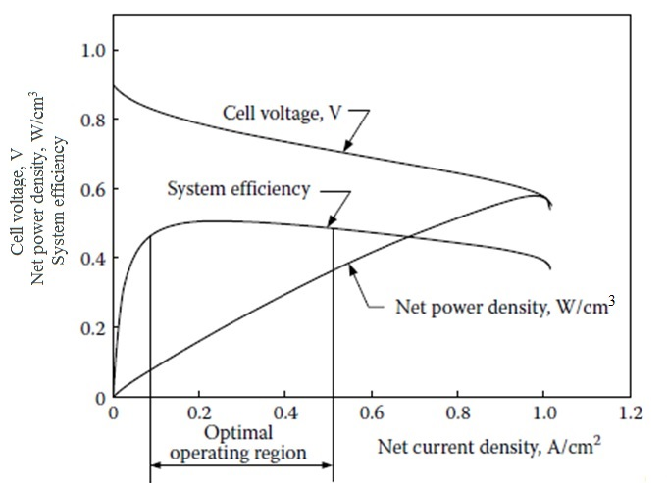
Figure 5: fuel-cell system operating characteristics^{[4]}

1.4 Classification of Hybrid Vehicle Based on Powertrain Configuration
The hybrid vehicles can be classified according to power train configuration into series, parallel and combined configuration as follows.

1.4.1 Series configuration
In series hybrid one energy converter can provide power for propulsion. The ICE is used to deliver power to an electric generator that charge batteries and drive the propulsion motor ^{[7]}. The system components of series hybrid electric vehicle is shown in Figure 6.
Figure 6: Series HEV drivetrain^{[5]}
Advantages of a series HEV are:
1. Location flexibility of ICE-generator unit.
2. Drivetrain simplicity.
3. Suitable for short drives.
The series HEV disadvantages are:
1. It needs three energy conversion units engine, electric generator, and electric motor.
2. The electric motor must be able to deliver the maximum required power. However, most of the time the vehicle is operated below the maximum power.
3. The three drivetrain power converter units must to be designed to operate at the rated power to sustain driving at high speeds for a long distance. That is because the batteries would be depleted quickly, leaving engine to deliver all the required energy through the generator.

1.4.2 Parallel configuration:
In a parallel hybrid more than one energy converter units can provide drive power to the vehicle. The internal combustion engine and the electric machine are connected in parallel, By coupling them mechanically and adding the torque coming from the two energy converters^{[7]}, as shown in Figure 7.
Figure 7: Parallel HEV drivetrain^{[5]}

The following are advantages of a parallel HEV:
1. It needs only two energy converter units: engine and an electric machine. The electric machine can be used as a generator or a motor.
2. A smaller motor and a smaller engine could be used to get similar performance, until the battery is consumed. Both of the motor and the engine can be sized at half the rated power to deliver the total power, assuming that the battery is never depleted. For long-distance driving, the ICE may be sized for the rated power, while the electric machine may be sized to half the rated power.
The following are disadvantages of a parallel HEV:
1. The a more complex control system is needed to be regulate the power flow from the two power sources.
2. The a mechanical coupling device is needed to connect the electric motor and the ICE .

1.4.3 Series-parallel combination
In this configuration, the ICE can be used to recharge the batteries, this add a series element to the main parallel powertrain. This series element can charge the batteries during long idling periods^{[7]}. The arrangement of the component of a series-parallel combination hybrid is shown in Figure 8
Figure 8: Series-parallel combination HEV^{[5]}

1.5 Techniques to Enhance Hybrid Performance
As shown in figure 9 ^{[8]} there are different techniques to improve the fuel consumption of a HEV based on the relative sizing of the internal combustion engine and the electric motor which is called Hybridness (H).

 | $$H=\frac{Sum of traction electric motors power }{Sum of tractionelectric motors power+Engine power}$$ | (1)

1.5.1 Engine start stop
The most common method to improve fuel consumption is by turning the engine off during stops in traffic. With the powerful electrical motors, the engine speed can be easily increased to the operating rpm.
Figure 9: Available techniques to enhance fuel consumption based on Hybridness^{[8]}

1.5.2 Damping of driveline oscillations
The fuel consumption can be reduced by to shutting off fuel injection when the brake pedal is applied. But sudden turning off of the fuel flow create unpleasant oscillations in the engine and the driveline. Active damping by the use of the electrical machine can reduce the oscillations to an acceptable level.

1.5.3 Vehicle launch
Due to the low torque and efficiency of ICE at low rpm an electric motor with a high torque at low rpm can be used to fill the torque gap. Using a small electric motor can help significantly to the initial vehicle launch.

1.5.4 Regenerative braking
For small values of Hybridness small generator is used, the small generator unit cannot harvest the vehicles kinetic energy during a fast stop. However acceptable regenerative braking energy could be absorbed when the hybridness is about 40%.

1.5.5 Motor assistance
Vehicle launch can be considered as a motor assist, but it is applied at slow driving speeds. However motor assist can be used in higher driving speeds and more demanding vehicle operating conditions such as climbing hills and snow driving. Larger and more powerful electric machines are required. Increasing Hybridness to about 50% generates enough power from the electrical machine to cover the lake of acceleration due to the engine downsizing.

1.5.6 Electric-only propulsion
During electric drive the ICE is turned off and there is no fuel consumption. Electric drive improves overall fuel consumption. To achieve the required performance, the electric motor has to be powerful enough to drive the car. At H = 50%, the electric motor is as big as the ICE. Alone, the electric motor yields the required performance. Also the electric-drive operation is preferable because of the low emissions. strict emission regulations can be met by electric-only propulsion.

1.5.7 Downsize engine
This is a result of the existence of the electric drive the ICE size can be reduced.

1.5.8 Miles per gallon gain
Due to the increases in hybridness, to about 50%, mpg increases also. This is a because of the balance between the available power and the required power. above 50% hybridness the mpg increase will be due to plug-in which requires external electrical energy from charging stations.

1.6 Organization of Thesis
The organization of this thesis is as the following:
Chapter 1 presents the motivation to this thesis and an introduction to the hybrid vehicles.
Chapter 2 presents the literature review performed in the scope of work.
Chapter 3 presents the modelling and simulation.
Chapter 4 presents control system strategies.
Chapter 5 describes the experimental part of the research.
Chapter 6 presents simulations and experimental results.
Chapter 7 presents conclusions and recommendations for the future work

CH:2
LITERATURE REVIEW
Several studies have investigated the hybrid control system in the last decade. Recent relevant research contributions are presented in this chapter.
The literature survey is divided into two main sections:
- Hybrid control strategies
- Hybrid vehicle modeling and simulation

2.1 Hybrid control strategies
based on genetic algorithm Morteza and Mehdi^{[9]} developed an optimal energy management system for HEV. They investigated the effects of different component layouts of powertrain systems in a variety of driving cycles. Using ADVISOR they compared the HEV simulation results for default rule-based, fuzzy and GA-fuzzy controllers. Their results indicated the overhand of optimal controller on real world driving cycles. Furthermore, they proposed an optimal powertrain arrangement to enhance the emission efficiency and fuel consumption for all driving circumstances. At last, the effects of hybridization and batteries initial SOC on hybrid electric vehicles performance were inspected to evaluate fuel efficiency and emissions. Fuel consumption was reduced by about 14% by using optimum power train configuration if compared to the default configuration. Also the results showed that the proposed controller had reduced emissions by about 10% in various driving conditions.
S. Hong et al ^{[10]} used two motors to assist the ICE or to recharge the batteries. The control algorithm was built so that it was able to control the torque of each of the two electric motors, to allow the ICE to operate near the optimal operating line by increasing the engine output torque in the Q zone and increasing the power in the P zone based on the ICE power and available battery power to achieve the driver’s acceleration demand as shown in
figure 10.

Figure 10: Optimal operation line^{[10]}
Poursamad and Montazeri^{[11]} used a Genetic-fuzzy control strategy for parallel hybrid electric vehicles. The genetic-fuzzy control strategy is a fuzzy logic controller, which was tuned using genetic algorithm. The target was the emission minimization, fuel consumption reduction and maintaining the vehicle performance characteristics within acceptable limit. The tuning process was done to maintain the computational efficiency, using expert knowledge, together with global optimality and diversity of solution. The rule base of the fuzzy logic controller was designed based on the knowledge of experts. By utilizing this method, the performance of the tuned fuzzy logic controller could be easily expected. The results of the simulation showed the effectiveness of this method with regard to improving the driving performance. An important result was that the parameters of the fuzzy control strategies affected the hybrid electric vehicle driving performance characteristics and that the control strategies must be designed such that driving requirements were met. Three different driving cycles were used and the results showed that the tuning process was affected by the selected driving cycle characteristics therefore an optimal set of membership functions for a driving situations was not necessarily optimal for another driving cycle.
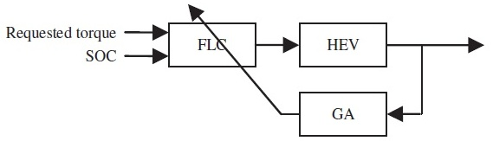
Figure 11: The schematic of control strategy tuning phase^{[11]} .

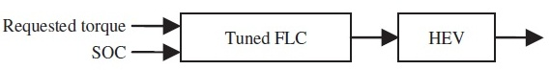
Figure 12: The schematic of control strategy application phase^{[11]} .
Chen et al^{[12]} focused on developing an efficient, intelligent and online energy management controller to decrease the fuel consumption of a plug-in hybrid electric vehicle. By using dynamic programming (DP) the battery current was optimized to decrease the fuel consumption. Six drive cycles divided into three types urban, urban (congested), and highway were used. The intelligent online energy management controller consisted of two neural network modules the NNs were trained by using the results from the dynamic programming methods, taking into consideration the trip duration and length. Depending on the availability of the trip duration and length, the controller would select the corresponding NN module that will be used to calculate the electric battery current command to achieve the required energy management. Simulation results showed that the developed controller can decrease the fuel consumption of the vehicle. The developed controller managed the energy distribution between the ICE and the electric motor more intelligently in comparison with the conventional charge depleting and charge sustaining control approach. When the trip duration and length were known and the length of trip was greater than the all electric range, the neural network 1 would be used as shown in Figure 13 to calculate the optimal battery current commands based on the vehicle target velocity and the other related parameters. When the trip length was less than the calculated all electric range, the battery would be used first to drive the vehicle. When the controller was no able calculate the trip duration and length before the start of the trip, the vehicle would be using the electric battery first until the battery state of charge droped to the preset lower limit, and then neural network 2 would be used as shown in Figure 14 to calculate the optimal battery current commands. However, the controller had been only validated by simulation and the results showed the effectiveness of the developed controller in reducing fuel consumption.
Figure 13: NN controller N1 trip duration and length were known^{[12]}.
Figure 14: NN controller N2 trip duration and length were unknown^{[12]}.

2.2 Hybrid vehicle modeling and simulation
Ambuhl et al ^{[13]} presented a realistic and simplified model of a HEV powertrain and used it to develop the solution of the optimal energy management. The optimal control problem solution consisted of rules that depended on parameters of the powertrain only as shown in Figure 15 where electric motor (EM) and the internal combustion engine (ICE) are static blocks while battery (BAT) is a dynamic block with state variable. Then the simplified model was validated by using a more complex model depending on actual measured values.
Figure 15: block diagram of the parallel hybrid electric powertrain^{[13]}
Markel et al. ^{[14]} provides an overview of (ADVISOR) Advanced Vehicle Simulator ,the simulator is written in the Simulink/MATLAB environment. It was robust, flexible and supported analysis package for vehicle advanced simulations. It is manly used to determine the fuel consumption, the acceleration performance, and the gas emissions of the car that utilize alternative energy technologies such as electric motors, batteries, fuel cells and ICE in hybrid configurations as shown in figure 16 and 17. The backward-facing simulation approach was used in ADVISOR assuming the vehicle met the required target speed, No driver model was required in this model. Instead, the tractive effort needed to accelerate the car during the time step is calculated from the target speed. The needed tractive effort was then transformed into torque that must be provided by the mechanical components upstream, also the car’s linear velocity was changed into a required rotational velocity. then these calculations was carried backward through the powertrain, in the opposite direction of the power flow, then the consumed fuel or the consumed electrical energy were calculated that would be required to meet the target speeds.
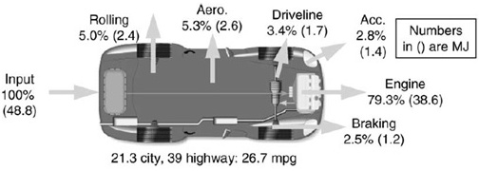Figure 16: Energy usage analysis of conventional vehicle ^{[14]}

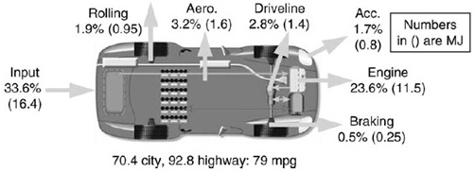
Figure 17: Energy usage analysis of a hybrid vehicle ^{[14]}

Figure 18: ADVISOR backward-facing block diagram for parallel HEV^{[14]}
Same et al.^{[15]}. three hybrid drive train configurations were investigated and their advantages and disadvantages the configurains were: series, parallel, and “through-the-ground” parallel. Simulink/MATLAB-based software (ADVISOR) was used to conducted the Power flow simulations. The simulation calculations were done by using ADVISOR using a combined backward/forward method. the simulations were used to know the effect of the fuel converter, motor, and hybrid configuration on the agility and efficiency. The simulations output were a group of plots of energy storage State of Charge and velocity profile that provided a reliable estimatation of the performance of the Formula Hybrid vehicle on the track. The most apparent divergence between the input driving cycle and the actual speed of the car happens during braking. Results showed that the
front-mounted motors with a through-the-ground parallel configuration accomplished the best balance between simplicity and efficiency.

Figure 19: common forward-facing simulation approach^{[15]}
Figure 20: common backward-facing simulation approach^{[15]}
In [16] Cipek, et al. used a bonded graph modeling approach to simulate the performance of the dual mode series–parallel HEV mechanical transmission. The essential advantages of this modeling method is a direct way of changing the mechanical physical system to a bond graph mathematical model, ease of management of repeated variables and modularity of the model. This developed a minimum-realization dynamics model suitable from the control system design point of view. The major benefit of the power split transmission was its capability to control the engine rpm by using rpm control of the high-bandwidth electric motor, this made the engine rpm virtually independent of the car speed. Therfore, the engine could be operated inside the low fuel consumption or/and low-emission operating zones in almost all the operation modes during the standard driving cycles. PI controller is used for low level transmission control the pi controller controlled the electric motor rpm and was tuned according to balanced optimum criteria. A (BPTT) Backpropagation through time method like the conjugate gradient-based optimization algorithm was used to get the optimum control variables of the ICE rpm and torque of the dualmode series–parallel hybrid vehicle transmission for The New European Driving Cycle. The parameters optimization had been based on a backward power train model with the batteries SOC as the model variable, the other variables had been considered as model outputs or inputs. The fuel consumption was set as the optimization target, while satisfying the mechanical transmission constraints and SOC limits. The optimization results showed that the ICE operated near its maximum efficiency zone, while also satisfying the SOC limits. The used model and optimization method provided the base of the optimum energy management and similar online high feedback levels control strategies.

Figure 21: Forward model block diagram for a power split HEV^{[16]}

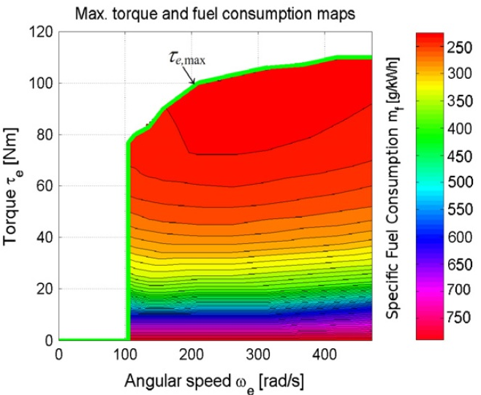
Figure 22: Engine fuel consumption map^{[16]}
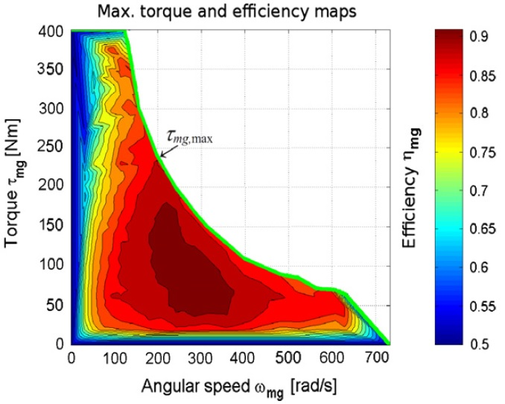
Figure 23: Electric motor generator efficiency map^{[16]}

From the above review it is obvious that the hybrid vehicle control strategies can be classified in a rule based control technique, fuzzy logic control technique, dynamic programming control technique and neural network controller technique. In the modeling topic there are two main vehicle modeling approaches; the forward-facing modelling approach and the backward-facing modelling approach.
The aim of the present work is a control strategy development for a post transmission parallel-hybrid single seated car which will be accomplished by proposing a vehicle model suitable for building a control algorism. after that a software in a loop approach will be performed on the proposed controller, then this controller will be implemented and validated experimentally.

CH:3
MODELING AND SIMULATION
This chapter starts with the modeling approach then describes the mathematical modeling of the system. The model is divided in three main parts; as shown in figure 24 the first part is the vehicle model in which all the physical parts of the vehicle will be modeled mathematically. The second part is the driver model. In this subsystem a human driver behavior will be presented to achieve a selected driving cycle. The third part is the control system which will be described in detail in chapter 4.
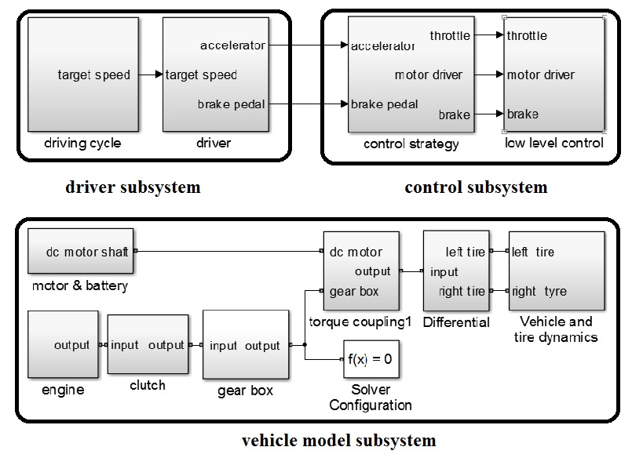
Figure 24: Overall system simulink model block diagram

3.1 modeling approach
Drivetrain modeling approaches are based on the objective of the modeling process in three main categories quasi-static, low-frequency and the high-frequency model as shown in figure 25

Figure 25: Power spectrum schematic of the of the vehicle acceleration and the used modeling approch^{[17]}.
Quasi-Static Models: Static and quasi-static models are treated under the same category since both types of models serve similar purposes. The main objectives are to evaluate the performance characteristics, fuel economy and exhaust emissions of vehicles over pre-determined test cycles. The preliminary design and testing of high- level control strategies for HEVs are usually done using quasi-static vehicle models.^{[17]}

Low-Frequency Dynamic Models: In addition to the benefits of quasi-static models, low-frequency dynamic models provide further insight into driveline and vehicle dynamics that have impact on the drivability, transient response and stability of the vehicle.^{[17]}
High-Frequency Dynamic Models: These types of models are generally developed to analyze the noise, vibration and harshness (NVH) characteristics of vehicles. Finite-element models are often utilized for analysis.^{[17]}
Mixed-bandwidth vehicle simulators and modeling environments that combine quasi-static and dynamic component models have also been developed. These types of models generally aim to serve specific purposes. For example, the Simscape SimPowerSystems SimDrivelineTM toolbox, developed by The MathWorks Inc.^{[19]}, is a modeling environment that incorporates dynamic models of driveline components (such as the transmission and the tires) in addition to a number of quasi-static models that characterize the behavior of the components upstream from the transmission (such as the engine and the torque converter). A study by ^{[20]} describes the development of an HEV simulator with emphasis on the dynamic modeling of the power electronics. Another example of mixed-bandwidth HEV models is based on a simplified longitudinal drivetrain model of a series HEV^{[21]} using combined detailed lateral dynamics to facilitate the development of a vehicle stability controller.
Mixed-bandwidth combining quasi-static and Low-frequency dynamic vehicle model is built with forward-looking calculation approach with the objective of predicting the transient behavior and the steady state performance of the power train. This model will be presented in detail in the next section.

3.2 Vehicle model
The vehicle model is divided into seven parts representing all the physical parts of the vehicle, mainly, the vehicle and tire dynamics, final drive, gearbox, clutch, electric drive, engine and torque coupling.

3.2.1 Vehicle and tire dynamics
This subsystem is divided in three main parts the vehicle longitudinal dynamics, the tire dynamincs and the brake system as shown in figure 26.
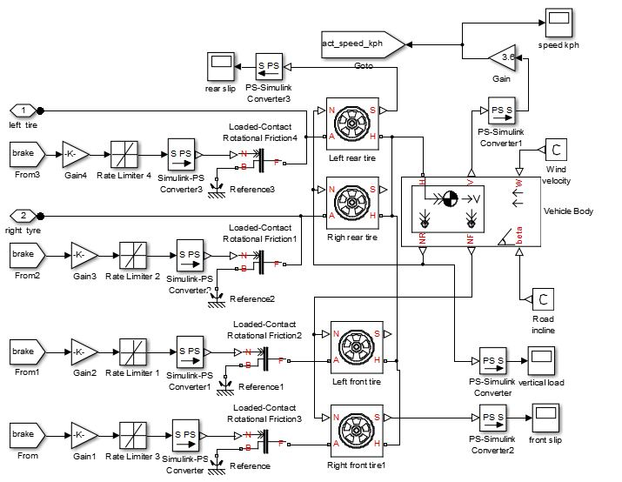
Figure 26: Vehicle and tire dynamics subsystem

3.2.1.1 Vehicle longitudinal dynamics
The first part is the longitudinal dynamics of the vehicle which was used to determine vehicle motion by calculating the resultant force on the vehicle. The tire forces act on the vehicle to the front or to the rear whether the vehicle is accelerating or braking. The weight of the vehicle acts downward at the CG of the car. The gradient angle pulls the vehicle either forward or backward. Aerodynamic resistance acts through the CG and is always acting against the direction of motion of the car.
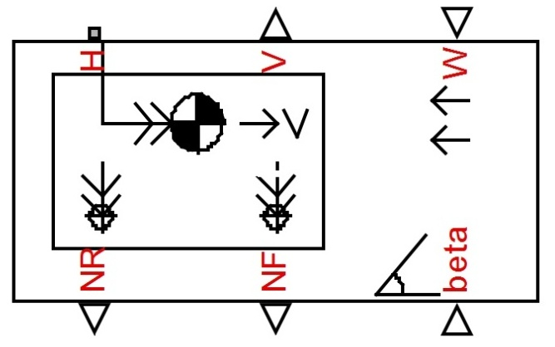
Figure 27: Vehicle body block^{[18]}
The input ports are wind velocity at port W and road gradient angle β at port beta. The block outputs are the vehicle speed at port V, the tires reactions at ports NR, and NF. The longitudinal force acting on the vehicle at port H.

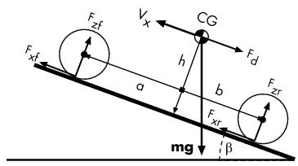
Figure 28: Vehicle model variables^{[18]}
The longitudinal acceleration is determined as follow^{[18]}:
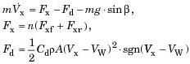
The front tires reaction:
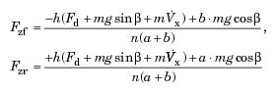

3.2.1.2 Tire longitudinal dynamics
In this part the tire longitudinal dynamics is represented by using Tire block, this model represents the tire as a rigid tire-wheel combination. The tire is exposed to slip with the road surface when drive force act on the tire, the tire reaction on the road surface is transferred a force back on the axle. This drives the vehicle forward or backward.

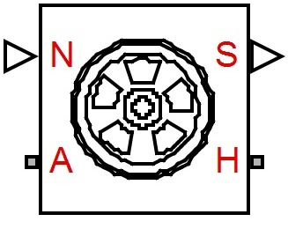
Figure 29: Tire (Magic Formula) block^{[18]}

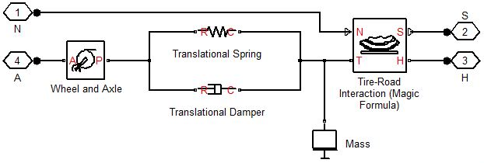
Figure 30: Tire transient and steady state behavior model^{[18]}

The tire simulation is based on the Magic Formula which is an empirical formula used for predicting the tire performance. The Magic Formula represents the relationships between the lateral force, self-aligning torque and longitudinal force with slip and slip angle as follow:
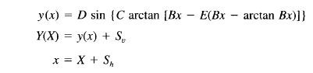
Where Y(X) is the lateral force, self-aligning torque, or longitudinal force and X is the slip or slip angle. B is the factor of stiffness, C factor of shape, D factor based on maximum value, and E factor of curvature. S_{v} and S_{h} are the vertical and horizontal shift^{[19]}.

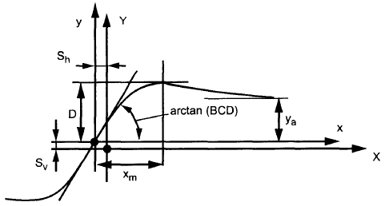
Figure 31: Parameters of Magic Formula ^{[19]}.

3.2.1.3 Braking system
The braking system was built using a loaded contact rotational friction block that transmits torque between a rotating shaft and a fixed end. The braking torque operates when the normal force presented at the physical signal port N is applied. Then the torque is transmitted to the tire model to calculate the slip and determine the lock condition.
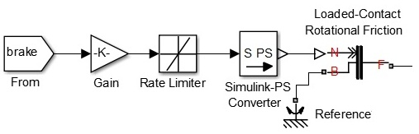
Figure 32:Braking model subsystem

3.2.2 Torque coupling
The function of the torque coupling is to connect the electric motor power and the engine power to the final drive, the coupling type used in this model is a chain drive.

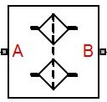
Figure 33: Chain drive block^{[18]}

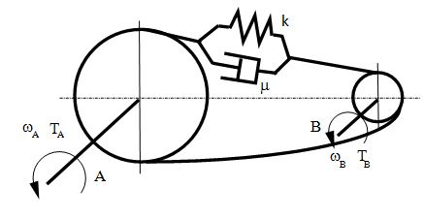
Figure 34: Chain model variables^{[18]}
The block represents a drive built of two sprockets that are connected by a roller chain. The model accounts for the transient characteristics of the chain through stiffness that counteracts stretching and damping relative to its linear velocity, for steady state the transmitted torque will be:
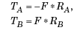

3.2.3 Final Drive
The Differential is represented by a Simscape differential model block that connect rotational motion from the transmission output shaft to two lateral shafts to drive the rear tires of the vehicle this is done by using a crown gear that drive the carrier of the sun bevel gear that drive two planet gears at the output shaft.

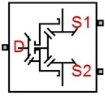
Figure 35: Differential model block^{[18]}
D is the input longitudinal driveshaft, S1 and S2 are the side output shafts, and the two respectively. The kinematic relations between the three connected axes are as follows:
The power constraint is:
Neglecting the friction losses yields

3.2.4 Gearbox and clutch
The gear box was built using two gear blocks to achieve the required reduction ratio and a loaded contact rotational friction block functioning as a synchronizer and dog clutch when locked., The control signal was imported through a from block then passed through a gain and rate limiter then converted to a physical signal to activate the selected shift as shown
in figure 36.
In the gear block the viscous friction losses were neglected and replaced with a constant transfer efficiency.
The loaded contact rotational friction the viscous friction is neglected and only a constant kinetic friction coefficient is used until the clutch is locked.

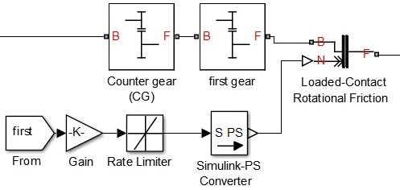
Figure 36: First gear model
For the gear kinematic constraint on the two connected axes is
The torque transfer is
For the loaded contact rotational friction block the friction torque is determined with the following equation until the two rotating bodies are locked.

3.2.5 Clutch
The clutch is built using a loaded contact rotational friction block. The block has two rotational ports and a normal force input. The block simulates friction between two rotating bodies loaded with a normal force. The viscous friction is neglected and only a constant kinetic friction coefficient is used until the clutch is locked.
Normal force input signal is imported by a from block then passed through a gain , a rate limiter and a signal converter .The gain and rate limiter parameters were optimized to achieve a smooth engagement and a stable lock under operating conditions.
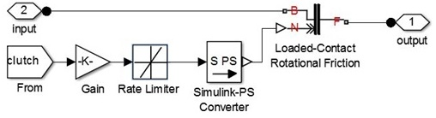
Figure 37: Clutch subsystem model

3.2.6 Motor
The motor model was based on a DC machine block. The DC Machine block used a wound-field direct current machine. The field current was supplied through terminals F+ and F− as shown in figure 38, The stator current is supplied through A+ and A−.
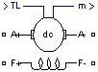
Figure 38: DC Machine block^{[18]}.
The CEMF is proportional to the rotational speed^{[20]}.
The voltage constant K_{E} is directly proportional to the current in the field winding.
The developed torque motor is directly proportional to the current in the armature.
The torque constant is equal to the K_{E}.
The mechanical part implements this equation:
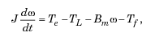

3.2.7 Battery
A generic battery block was used to simulate the battery. The block outputs are the SOC of the battery between 100 and 0% ,the Battery current and the voltage. Also there are physical terminals one for the positive and the other for the negative.
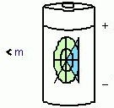
Figure 39:Generic battery model block^{[18]}
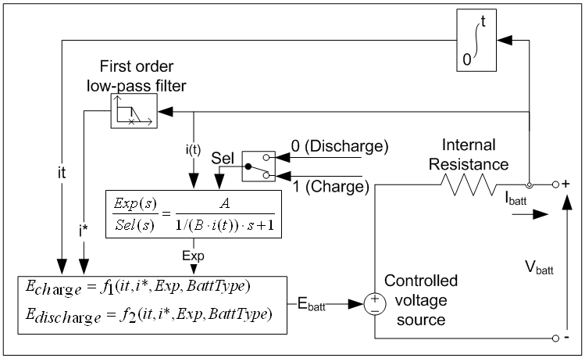
Figure 40: The equivalent circuit used in the battery model^{[21]}.
For the lead acid battery model ^{[21]}
During discharge (i* > 0)
During charge (i* < 0)
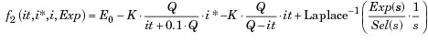
A constant internal resistance was assumed in this model during the charge and the discharge cycles and doesn't change with the current. The model variables were determined during discharge and then the charging characteristics were assumed to be similar. The battery capacity didn't change with the current amplitude. The heat generated by the internal resistance was not calculated in this model. The memory effect and the Self-Discharge of the battery were not represented.

3.2.8 Engine
The engine model is based on the generic engine model block. The block represents a general internal combustion engine, which utilize a relationship between engine rpm and output torque, that can regulated by the throttle signal.
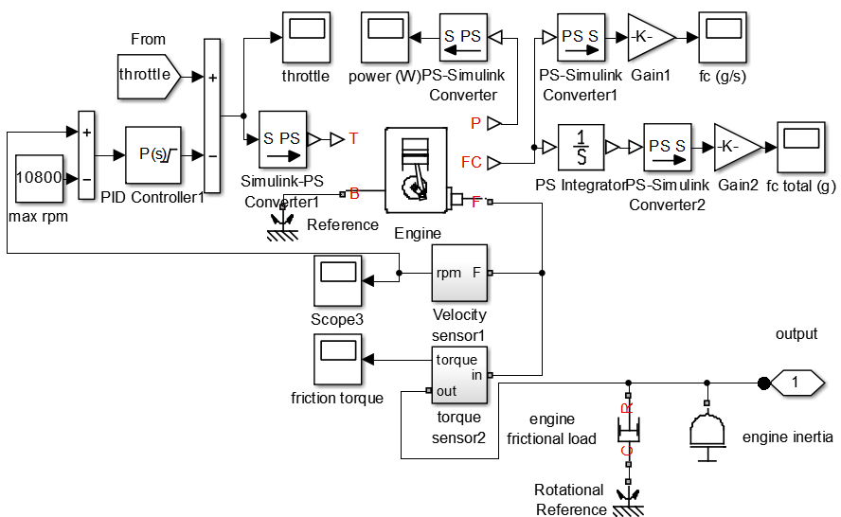
Figure 41:ICE subsystem

The throttle signal is imported from the low level control subsystem then modified by a proportional controller to limit the maximum engine speed. The fuel consumption output port represents the ICE fuel consumption rate based on the efficiency map. The fuel efficiency map of the ICE was obtained during steady state operation of the vehicle on an inertia chassis dynamometer. The fuel consumption map then extrapolated to maintain the typical profile of the engine map as shown in figure 42,43^{[22]}. The generated engine map used in the model is shown in figure 44.

Figure 42: Typical fuel consumption map of a spark ignition engine^{[4]}

Table 1: Typical values for fuel consumption at the best point^{[4]}
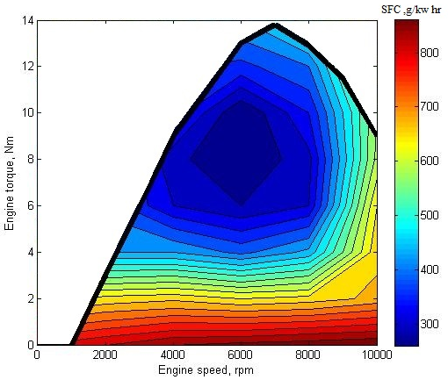
Figure 43:fuel consumption map

3.3 Vehicle model parameters identification
The vehicle parameters was identified experimentally by performing a full load acceleration from rest until the car reach the maximum speed using the electric drive only then power supply is cut and the car is left to coast down. The same test was performed on the model and the friction and inertia parameters were modified until the same performance was obtained.
Also, the same test was performed by using the ICE to detect the inertia of the rotating parts and the engine braking effect.
The test results showed agreement between both the experimental and the model results as shown in figure 73 which will be discussed in detail in chapter 6.

3.4 Driver model
The driver subsystem objective is to simulate the human behavior to achieve a required driving cycle. The driving cycle is generated by using a
1-D lookup table then multiplied by a scaling factor^{[23]} so that the cycle speed requirements can be fulfilled without exceeding the limitations of the vehicle. The actual vehicle speed is subtracted from the target speed to calculate the error. Based on the error value, a stateflow chart decide whether to accelerate by activating the accelerator PI and resetting the brake PI controller, or to decelerate by activating the brake PI and resetting the accelerator PI controller.

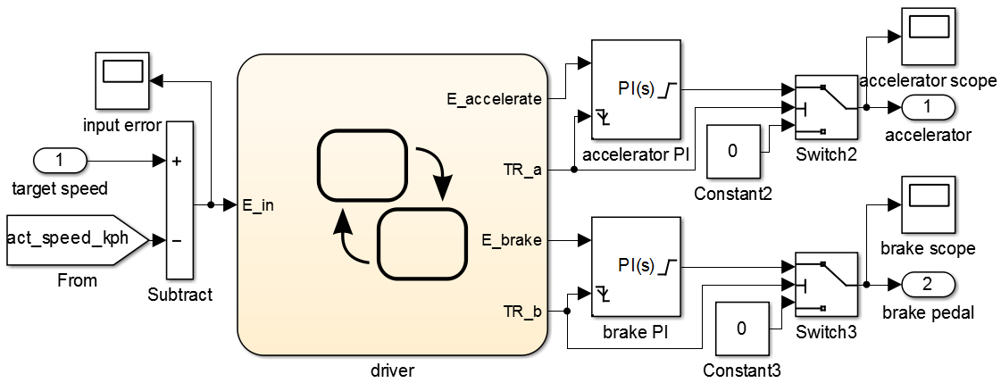
Figure 44: Driver model subsystem

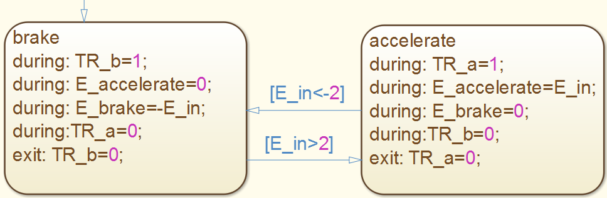
Figure 45: Driver accelerate and brake states selection
The driver model passed through several optimization processes until it was able to achieve a good driving cycle tracking performance and will be shown in chapter 6.

CH:4
CONTROL SYSTEM
A control algorithm has been developed and is divided into main parts .The first part is the low level control which is used to select the optimum gear shift and limit the engine throttle position to avoid engine exceeding the max speed limit and also control the clutch engagement and disengagement rates. The second part is the hybrid control strategy which is responsible for controlling the motor and engine states. The developed control strategy has three approaches that will be discussed in the control strategy section.

4.1 low level control
The objective of the low level control is to make sure that a correct output is given to the different power train related actuators in both the simulation and the experimental setup.
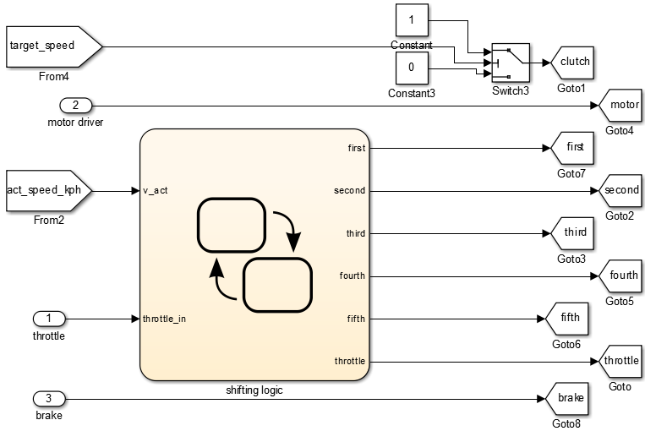
Figure 46: low level control
The low level control is divided in five main parts as follows;

4.1.1 Cutch control
The clutch control main objective is to avoid the engine stall during low speed and minimize sudden change in acceleration during engagement and disengagement of the clutch. The first objective was achieved by using a switch that starts to disengage the clutch in case the target speed is below an allowable threshold and reengage the clutch above this speed. The second objective was achieved by using a rate limiter shown in figure 37 which was able to perform a smooth engagement.

4.1.2 Shifting logic controller
The shifting logic objective is to select the correct shift and to engage this shift without any sudden impacts in the power tain and to make sure the engagement is only done after the previous shift is completely disengaged.
This was achieved by using the state flow with the main state of the transmission is the neutral state from which 5 shift up and 5 shift down set points was optimized to maintain the engine in the economical operation range. If the shifting condition set point is met the shift process is started into two main stages; The engagement process in which the engine throttle input is reduced to zero to achieve a smooth revolution matching across the transmission after the temporal logic requirement is met for this state the transition to the next state. The locked state is done in which the throttle signal is allowed to reach the internal combustion engine to start the flow of the power to the rest of the powertrain figure 47 and 48 show the details of the shifting logic.

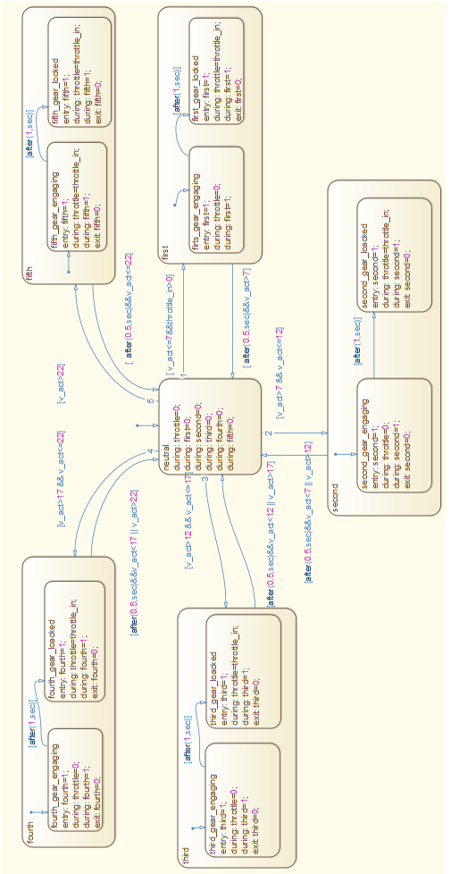
Figure 47: Shifting logic
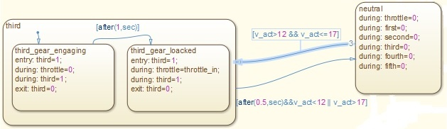
Figure 48: A closer view of the shift logic (third shift only)

4.1.3 Throttle control
The internal combustion engine throttle controller main objective is to restrict the engine in the safe operating speed, maintain a stable idle speed and avoid any hard shifting.
The engine speed is limited by using a proportional controller tuned to only operate near the max safe engine speed. Once this limit is reached the controller starts to reduce the throttle signal reaching the engine which reduce the engine output power and reduce the speed. The engine speed limiter is shown in figure 49. The idle speed is controlled by adjusting the throttle position to increase the ICE speed above a target speed. The hard shift is avoided by the shifting logic stated in the above section which ensures a good synchronization between the gear box and the engine.
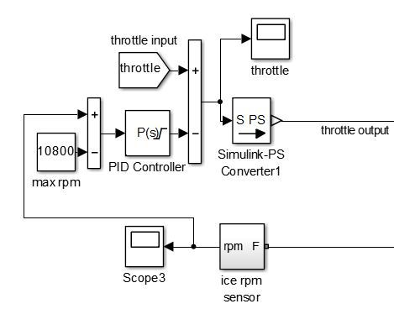
Figure 49: Engine rpm limiter set to 10800rpm

4.1.4 Brake control
The brake control objective is to sustain a good brake force distribution between the front tires and the rear tires, also, to achieve smooth braking. This objectives were achieved by using a gain block(shown in
figure 32) which is optimized for the front tires and rear tires separately to accomplish a good distribution . The smooth brake force was done by using a rate limiter.

4.1.5 Motor control
The motor controller consists of pulse width generator which change the pulse width of a signal delivered to two switches that control the field and the armature currents and change the output torque of the electric motor.

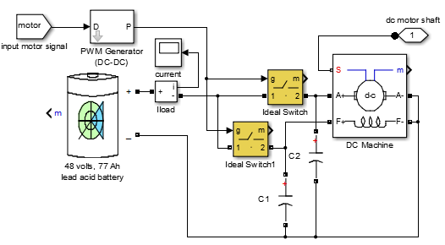
Figure 50: Motor controller

4.2 Control strategy
In this section three potential control strategies will be discussed in detail as follows:

4.2.1 Conventional engine control strategy
The first and the most common control strategy is the Conventional engine control strategy in which the hybrid vehicle is operated as if it is not equipped with an electric power train and the main motive force is from the ICE . To do this, the input to the electric motor was set to zero and the internal combustion engine is operated during the entire duration of the cycle. The driver command is sent to the internal combustion engine without any changes except during the gear shifting process .Figure 50 shows the engine states during this control strategy. The default state is the ready state in which the engine will keep operating and there is no transition condition to the off state.

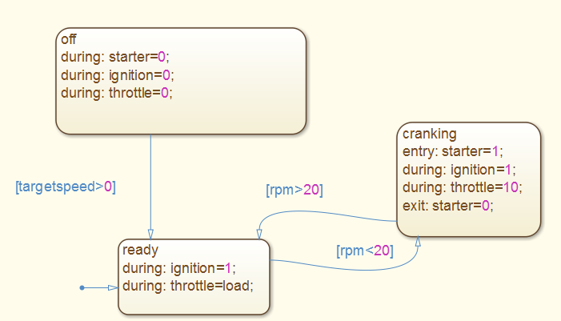
Figure 51: Engine states during the Conventional control strategy

4.2.2 Engine on-off control strategy
In the Engine on-off control strategy the hybrid vehicle is operated as if it is not equipped with an electric power train also and the main motive force is from the internal combustion engine, but the engine will be shut down during the idle time to minimize the fuel consumption. To do this, the input to the electric motor was set to zero and the internal combustion engine is operated using an on-off strategy based on the target speed required from the vehicle as shown in figure 51. The default state is the off state and the engine will start only if the target speed is above zero. When this condition is met the engine state will change to ready from which the state will change to cranking to start the engine smoothly with a ten percent throttle opening then at 2000 rpm the cranking process is ended and the state of the engine is changed to ready to deliver the required torque to the power train
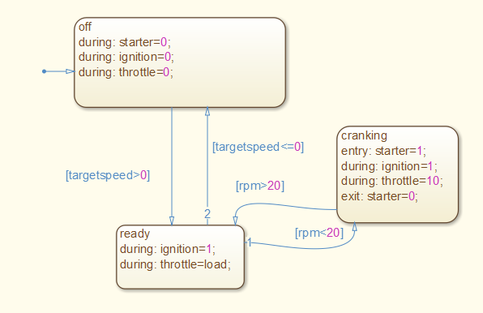
Figure 52: Engine states during the on-off control strategy

4.2.3 Launch assisted control strategy
In the Launch assisted control strategy in which the electric power train is used to launch the vehicle from standstill then the internal combustion engine will be turned on and start to support the electric motor which will start to turn off at this point. The engine will be shut down during the idle time and when the target speed is less than 10 kph then will be started by the same method discussed in the previous control strategy. Electric motor will remain operational in second and third speed till a top speed of 12 kph then electric assistance will be turned off as shown in figure 53 and 54.
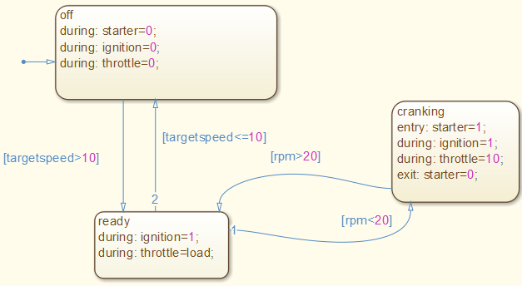
Figure 53: Engine states during launch assisted control strategy
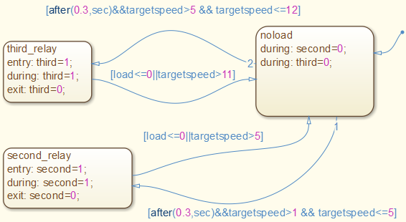
Figure 54: Motor states during launch assisted control strategy

4.2.4 Control strategy selection conditions
The mentioned control strategies can be used according to different criteria based on the advantages of each strategy. For the Conventional engine control strategy main advantage is that no electric energy is consumed so it is mainly used when the SOC of the batteries drops to a low limit which may affect the life of the battery. Engine on-off control strategy has moderate electric energy consumption during starting the ICE and can be used to achieve a reduction in fuel consumption especially during stop and go traffic. The Launch assisted control strategy increases the electric energy consumption but will be able to move the vehicle during low speed driving which will lead to increase the duration in which the engine is turned off which will reduce the fuel consumption.

CH:5
EXPERIMENTAL WORK
In this chapter the experimental work will be presented in three sections. The first section will describe the preparation of the experimental test rig. The second section will describe the selected cases, driving cycles and the. Test procedure the third section is about the limitations in the experimental setup that will require more modifications in the future.

5.1 Experimental Setup
A laboratory single seat car was modified to accommodate testing the mentioned strategies as follow.

5.1.1 Vehicle
The vehicle testing was performed on a rear wheel drive single seated prototype vehicle (shown in figure 55). The test vehicle was equipped with an electric motor to allow using both the ICE as well as the electric motor to drive the rear axle in a parallel post transmission hybrid configuration.

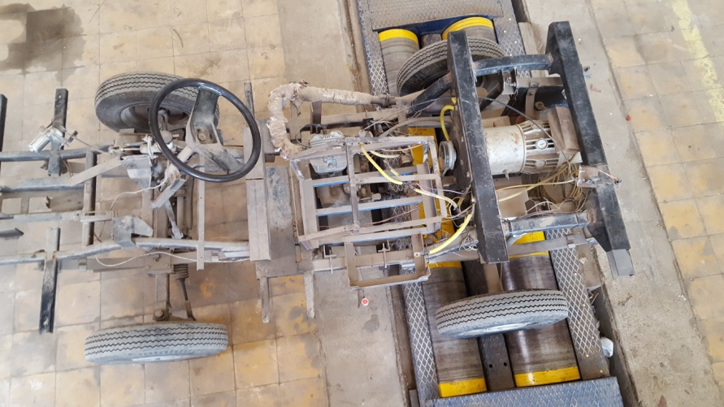
Figure 55: vehicle test rig

5.1.2 Internal combustion engine power train
A single cylinder air cooled engine was used to drive a sequential 5 speed gear box through a wet clutch then the motive power is transferred to the rear axle by using a drive shaft then the rear axle open differential split the power to the rear wheels of the vehicle.
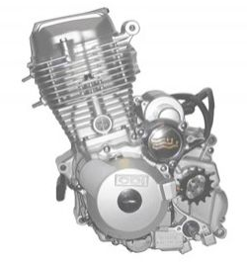
Figure 56: Air cooled engine used in the vehicle
A throttle by wire system was designed and was equipped to the engine so that the engine output power can be controlled electronically according to the control strategy. A servo motor was used to actuate the throttle valve.
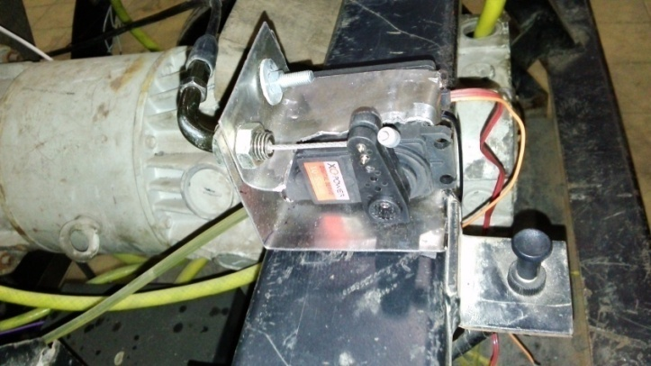
Figure 57: Throttle by wire actuator

A clutch by wire system was built to control the engagement and disengagement of the clutch especially during moving from rest or during shifting. The clutch actuator is activated manually by a bottom at the end of the shifting lever.
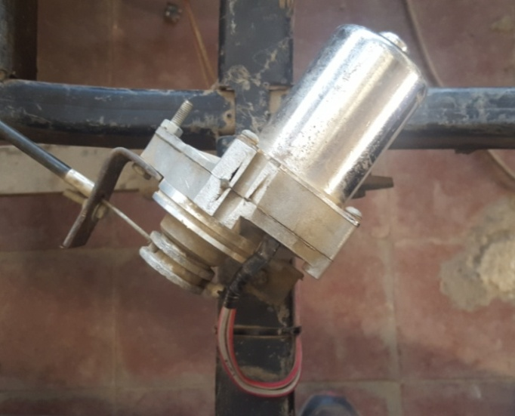
Figure 58: Clutch actuator

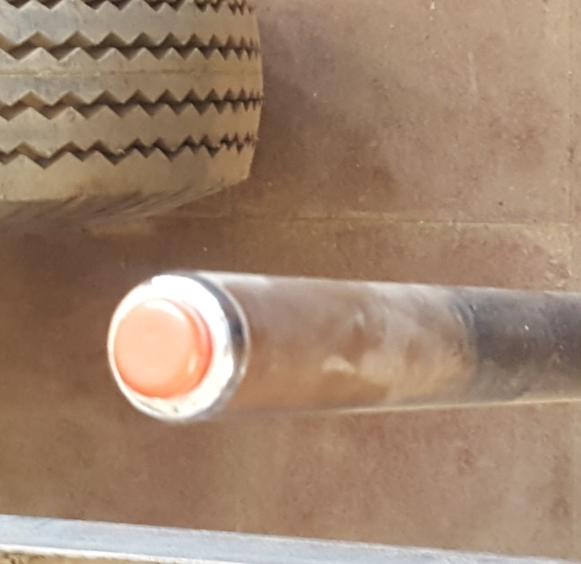
Figure 59: Shifting lever and clutch control bottom

5.1.3 Electric Power Train
A dc series motor drive the rear axle through a belt coupled with the input shaft of the differential capable of achieving a hybridness ratio of 10%. The electric motor is controlled by a discrete electro switch driver used to apply a constant voltage to the electric motor ranging from 0 to 48 volt by using of four relays.
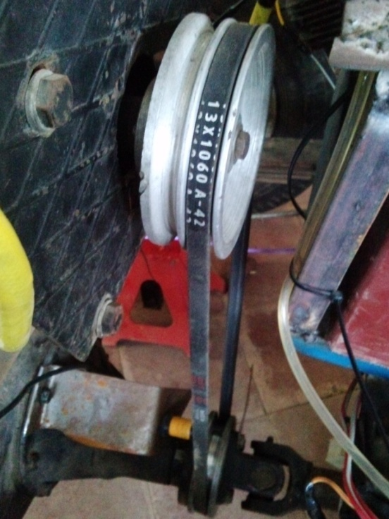
Figure 60: Belt connecting the motor pulley to differential pulley

5.1.4 Energy storage
Four 12V 62 A.h valve-regulated deep-cycle lead-acid battery ^{[24]} was used as the main energy storage of the electric energy needed to drive the motor. Each battery can deliver up to 1.19 kW-h at 100-h discharge rate.

5.1.5 Chassis dynamometer
An inertia type chassis dynamometer was used to apply a load on the vehicle during testing the selected drive cycles.

5.1.6 Control system

Two arduino boards microcontrollers were used to control the vehicle. The first one is used to control the location of the intake throttle valve of the internal combustion engine. The second and main control unit manage the electric motor, contain the control strategy and monitor the real time data. The reason to distribute the control system over two controllers instead of centralized control system is the limitation in the processing power available, The two controlling modules were communicated with each other by a controller network using a two wires UART communication protocol. The real time data of the vehicle is acquired by a laptop connected to the main control unit of the vehicle by using Matlab Simulink external mode.
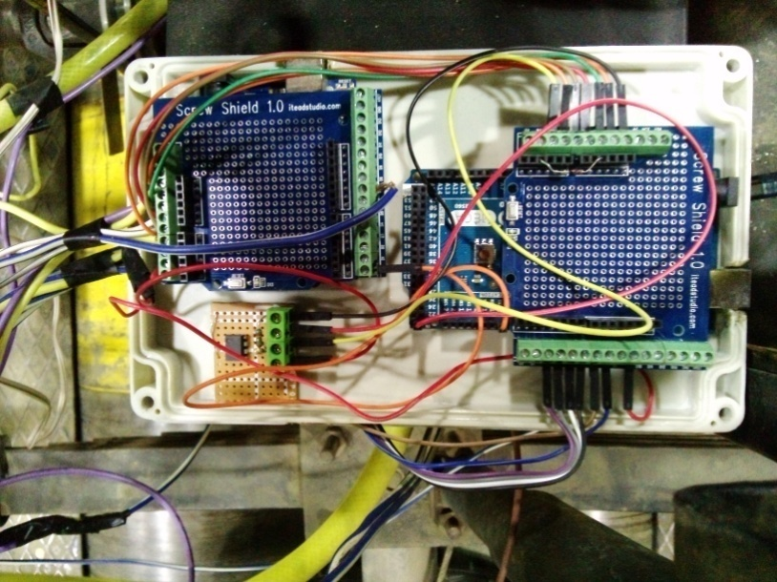
Figure 61: Two control modules inside the protective case
Control modules digital signal is then transferred to a main rely box to activate the main function of the vehicle. Each relay control a separate system of the car such as the ignition system, electric starter and the electric motor drivers. Both the relay box and the controller box are powered by two separate kill switches to enable powering the controllers first to upload the required control strategy.

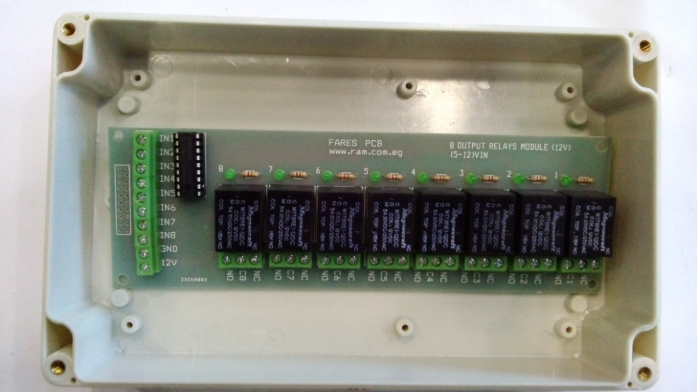
Figure 62: Main relay box

5.2 Measurement system and Experiment Design
To build a robust control system many physical properties were measured in the real time and acquired for further analysis.

5.2.1 Engine RPM measurement
The engine RPM is measured by using a frequency to voltage converter circuit that monitor the ignition coil input signal. The engine is a four stroke engine equipped with a CDI ignition system that generate a spark every revolution of the engine.
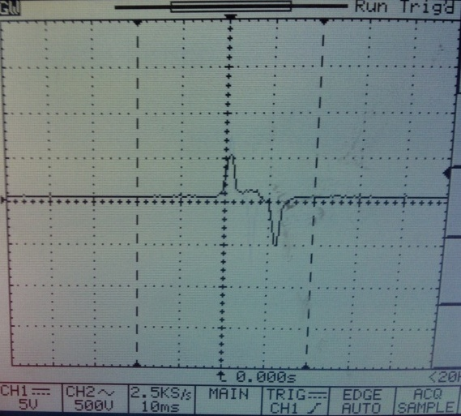
Figure 63: Shape of the ignition signal used for RPM measurement

The circuit used in the frequency to voltage convergence is shown in figure 64 the circuit gain parameters was optimized by using a function generator to ensure a reliable responsive reading in all the operating speeds of the engine.

Figure 64: RPM to voltage convergence circuit

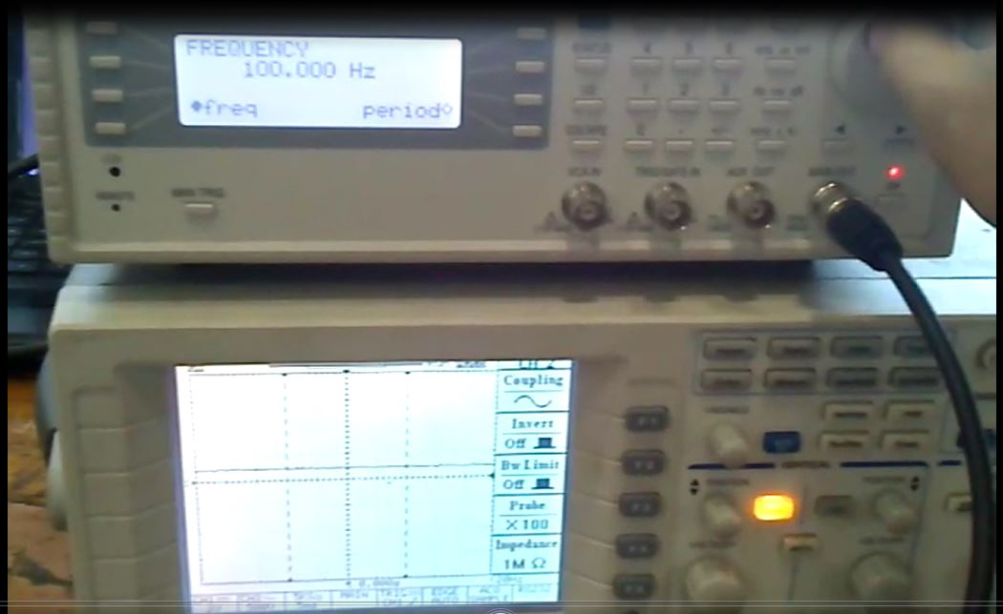
Figure 65: RPM circuit testing

5.2.2 Vehicle speed measurement
The speed is measured by using a frequency to voltage converter circuit similar to that used in RPM measurement by using an optical proximity sensor installed in front of an encoder connected to the input shaft of the differential(shown in figure 60). Then the output signal was calibrated by using an optical tachometer.
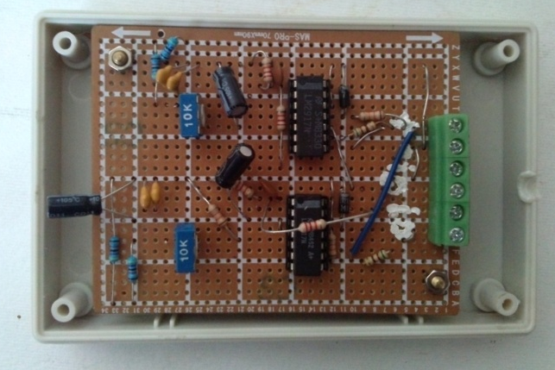
Figure 66: RPM and Speed measurement circuit

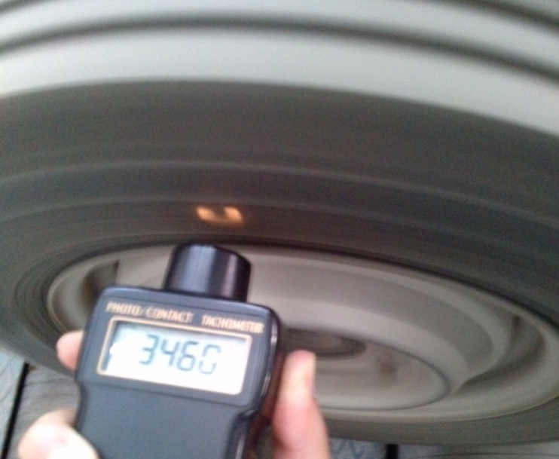
Figure 67: Speed measurement circuit calibration

5.2.3 Motor electric current measurement
The motor electric current was measured by using the main power line of the motor as a known value ballast resistance. The voltage drop across it was measured and amplified so that the output signal was linearly proportional to the motor electric current. The measurements were checked and calibrated by using a clamp meter as shown in figure 68.

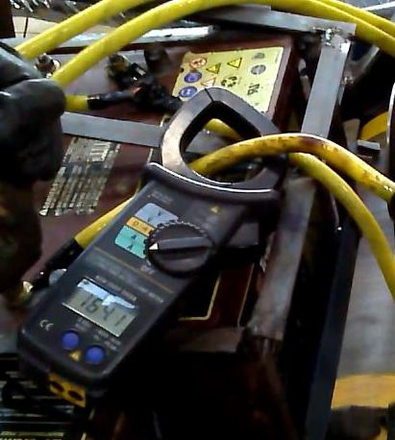
Figure 68: Electric current measurement system calibration

5.2.4 Accelerator pedal position measurement
The accelerator pedal position was detected by using a potentiometer that is supplied by a constant voltage from the controller. The signal is sent back to the input ports of the controller.
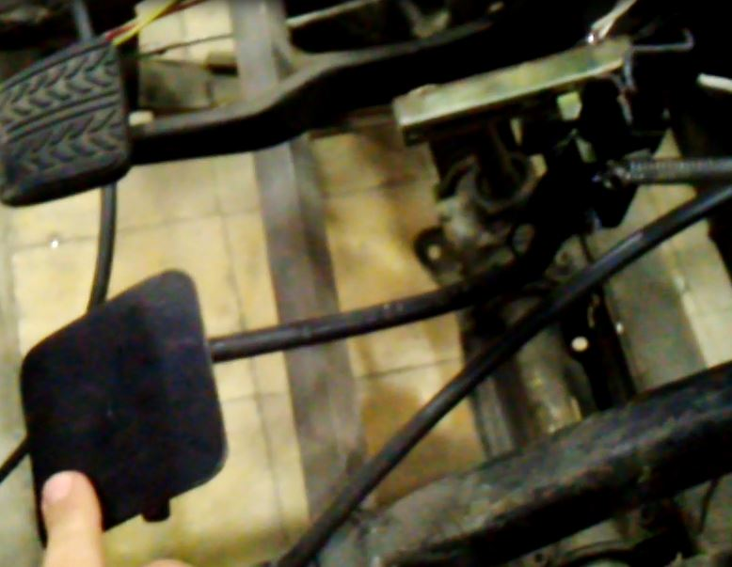
Figure 69: Accelerator Pedal equipped with a potentiometer

5.2.5 Fuel consumption measurement
A gravimetric fuel consumption measurement approach was used instead of volumetric measurements. The measurement is performed by using a digital scale with 0.01 gram sensitivity placed in a location isolated from the vibration and any wind currents to maintain the stability of the measurements, then the fuel is supplied by a transparent hose to the engine.

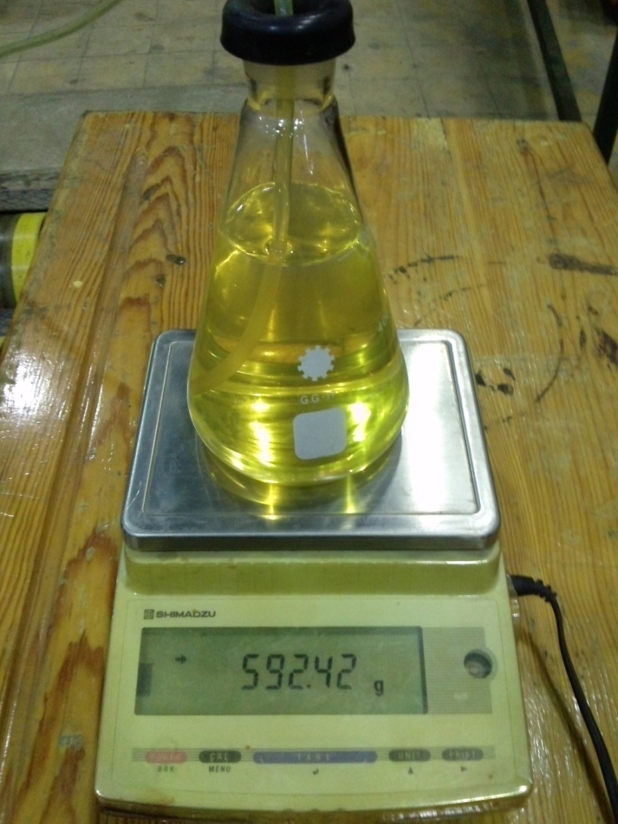
Figure 70: Gravimetric fuel consumption measurement

5.3 Experiment Design and Selected Cases
The internal combustion engine was warmed up before testing the selected cycles on the chassis dynamometer to avoid cold start drawbacks. The cold engine start generally affects both fuel consumption and vehicle drivability.The vehicle main control unit was connected to a laptop to upload both the control strategy and the required driving cycle. The real time data of the vehicle is then acquired by the laptop for monitoring and further data analysis by using Matlab Simulink external mode. When the vehicle and the control system are checked and ready, the digital scale (for the fuel consumption) is reset to zero and the driving cycle is performed. During the driving cycle the fuel consumption is recorded at the end of the urban sector of the cycle and at the end of the high way.

5.4 Limitations in Experimental Setup
The vehicle recharge capability was not implemented in this research due to the limitations in the experimental setup. This limited the utilization of the regenerative braking energy to recharge the batteries.
The maximum speed of the car was limited to 40 (km/hr) for the internal combustion engine and 16 (km/hr) for the electric motor operation. This affected the selection of the driving cycle and the cycle scale factor during performing the experimental trials.
The processing power of the controller was limited that required the control strategy to be simplified and two controllers were used instead of one centralized controller.

CH:6
RESULTS
The aim of this chapter is to show the experimental results for running the cycle jp10-15 and to show the correlation between the obtained results in simulation and experiment in order to validate the developed model that can be used to overcome the experimental setup limitations.

6.1 Engine Characterization
The engine rated torque and power were available in the engine manufacturer specifications, however, the fuel consumption map was not available. To find the fuel consumption the vehicle was driven with a constant speed .The same test was run on the simulation model to optimize the fuel consumption. The optimized points were extrapolated to maintain the typical profile of the engine map which was used in developing the control strategies specially the transmission shifting logic to maintain the engine in the most efficient zone.
Figure 71: fuel consumption map
T, N.m  N_{e}, rpm | 0 | 2 | 4 | 6 | 8 | 10 | 12 | 14
0 | 0 | 630 | 550 | 480 | 470 | 500 | 540 | 620
2000 | 830 | 660 | 440 | 400 | 400 | 380 | 495 | 660
4000 | 860 | 670 | 440 | 320 | 300 | 370 | 380 | 550
6000 | 870 | 650 | 400 | 290 | 260 | 260 | 370 | 440
8000 | 880 | 660 | 450 | 320 | 310 | 350 | 410 | 520
10000 | 890 | 690 | 670 | 650 | 600 | 590 | 650 | 710
Table 2: fuel consumption matrix in [g/kwh]

6.2 Simulation Results
A full load acceleration test was performed from rest until the car reach the maximum speed using the electric drive only then power supply is cut and the car is left to coast down. The same test was performed on the model and a good agreement between simulation and experimental results was found as shown in figure 72.
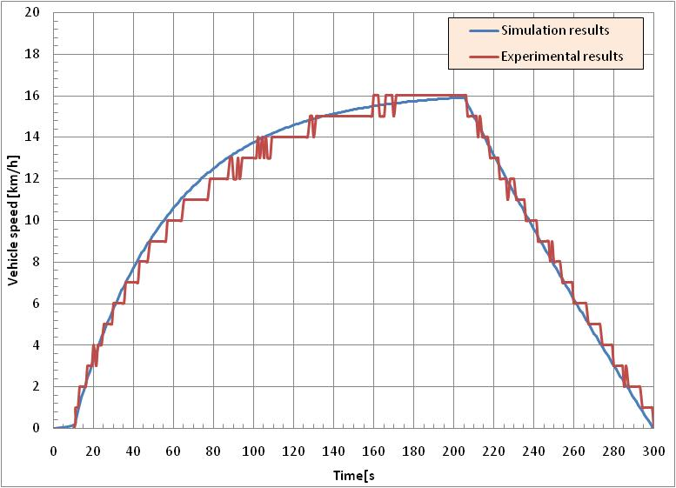
Figure 72: Full load acceleration using electric motor

The same test was performed by using the ICE to detect the inertia of the rotating parts and the engine braking effect. And a good agreement between both the model results and the experimental results was found as shown in figure 73.
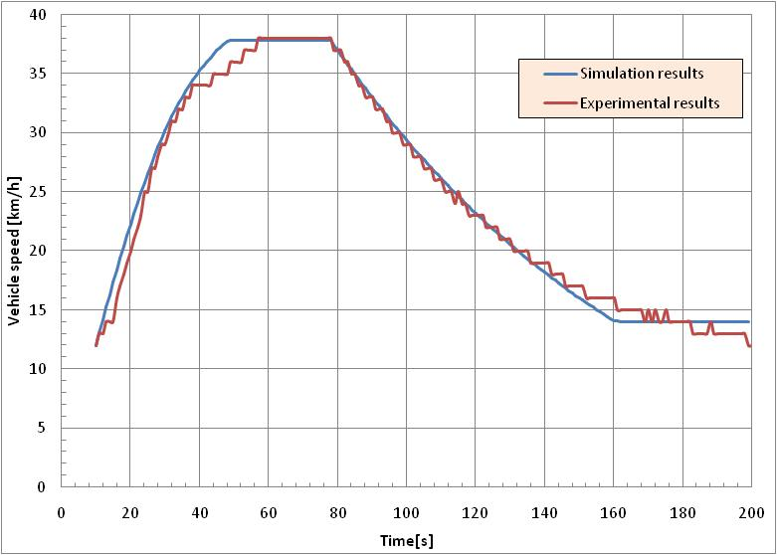
Figure 73: Full load acceleration using internal combustion engine

6.2 Experimental Results
The experimental test rig was used for running a 50% scaled jp10-15 cycle to overcome the experimental setup limitations mentioned before. The experimental test show a good cycle tracking of the vehicle.

Figure 74: actual vehicle speed using 50% scaled jp10-15 driving cycle

The urban, highway and the combined fuel consumption was measured for the three proposed control strategies as shown in table 3.
Fuel consumed in driving cycle [gram] | urban | highway | combined
Conventional control strategy | 79 | 51 | 130
Engine on-off control strategy | 60 | 43 | 103
Launch assisted control strategy | 37 | 41 | 78
Table 3: Fuel consumption for the jp10-15 driving cycle

Fuel consumption improvement compared to conventional control strategy [%] | urban | highway | combined
Engine on-off control strategy | 24.1% | 15.7% | 20.8%
Launch assisted control strategy | 53.2% | 19.6% | 40.0%
Table 4: Improvement Percentage in fuel consumption

For the hybrid control strategy the fuel consumption results represent the fuel consumed by the ICE as the electric energy stored in the batteries was supplied by using the electric outlet similar to plug-in hybrids. So, the results in the lunch assisted control strategy may vary from place to another based on the type of fuel used in the power plants whether it uses fossil fuel or renewable energy sources.

CH:7
CONCLUSIONS AND FUTURE WORK

7.1 Conclusions
Hybrid systems can develop into many types of configurations depending on the task and the space available. In this thesis, a parallel hybrid post transmission system topology was used for a personal single seated vehicle.
In order to develop a fast and accurate control system for the vehicle, the powertrain was modeled using Matlab Simulink, in conjunction with Simscape. The model was validated and showed good agreement with the experimental data.
In the hardware experiments there was a 20.8% improvement in the combined fuel consumption when using the Engine on-off strategy and a 40.0% improvement when using the Launch assisted control strategy compared to the conventional power train.
The Launch assisted control strategy fuel consumption great improvement was based on an external electric supply for charging the batteries which is recommended to be supplied from renewable energy power plants.

7.2 Recommendations for Future Work
As mentioned before the vehicle recharge capability was not implemented in this research. Due to the limitations in the experimental setup In order to make this a reality, a bidirectional buck-boost converter must be used to power the electric motor instead of the discrete electro switch driver, To allow the utilization of the regenerative braking energy to recharge the batteries and improve the overall fuel consumption of the system. The validated model can be used to simulate the performance of advanced control strategies such as neural controllers that cannot be tested on the test rig due to the high processing power required.

REFERENCES

[1] "2014 World Oil Outlook," Organization of the Petroleum Exporting Countries, 2014.
[2] "BP Statistical Review of World Energy," 2014.
[3] "Country Analysis Brief: Egypt," U.S. Energy Information Administration, 2014.
[4] Mehrdad Ehsani Yimin Gao Ali Emadi, Modern Electric, Hybrid Electric, and Fuel Cell Vehicles Fundamentals, Theory, and Design: CRC Press, 2010.
[5] Iqbal Husain, ELECTRIC and HYBRID VEHICLES Design Fundamentals: CRC Press, 2005.
[6] James Larminie John Lowry, Electric Vehicle Technology Explained: John Wiley & Sons, 2003.
[7] John M Miller, Propulsion Systems for Hybrid Vehicles: The Institution of Engineering and Technology, 2008.
[8] Allen Fuhs, Hybrid Vehicles and the Future of Personal Transportation: CRC Press, 2009.
[9] Morteza Montazeri Mehdi Mahmoodi, "An optimal energy management development for various configuration of plug-in and hybrid electric vehicle," Springer, 2015.
[10] S. Hong H. Kim J. Kim, "MOTOR CONTROL ALGORITHM FOR AN OPTIMAL ENGINE OPERATION OF POWER SPLIT HYBRID ELECTRIC VEHICLE," International Journal of Automotive Technology, 2015.
[11] Amir Poursamad Morteza Montazeri, "Design of genetic-fuzzy control strategy for parallel hybrid electric vehicles," Elsevier Control Engineering Practice, 2008.
[12] Zheng Chen Chunting Chris Mi Jun Xu Xianzhi Gong Chenwen You, "Energy Management for a Power-Split Plug-in Hybrid Electric Vehicle Based on Dynamic Programming and Neural Networks," IEEE TRANSACTIONS ON VEHICULAR TECHNOLOGY, 2014.
[13] Daniel Ambuhl Olle Sundstrom Antonio Sciarretta Lino Guzzella, "Explicit optimal control policy and its practical application for hybrid electric powertrains," Elsevier Control Engineering Practice, 2010.
[14] T. Markel A. Brooker T. Hendricks V. Johnson K. Kelly B. Kramer M. O’Keefe S. Sprik K. Wipke, "ADVISOR: a systems analysis tool for advanced vehicle modeling," Elsevier Journal of Power Sources, 2002.
[15] Adam Same Alex Stipe David Grossman Jae Wan Park, "study on optimization of hybrid drive train using Advanced Vehicle Simulator (ADVISOR)," Elsevier Journal of Power Sources, 2010.
[16] Mihael Cipek Danijel Pavkovic Josko Petric, "A control-oriented simulation model of a power-split hybrid electric vehicle," Elsevier Applied Energy, 2013.
[17] Kerem Koprubasi et al, "Modeling and control of a hybrid electric vehicle for drivability and fuel economy improvements," Research Gate Article, 2008.
[18] "Matlab help documentation."
[19] J Y Wong, Theory of ground vehicles 3rd ed.: John Wiley & Sons, 2001.
[20] Paul C. Krause et al., "Analysis of Electric Machinery," IEEE Press, 1995.
[21] Tremblay Dessaint et al., "Experimental Validation of Battery Dynamic Model for EV Applications," World Electric Vehicle Journal, 2009.
[22] Richard van Basshuysen Fred Schafer, "Internal Combustion Engine Handbook Basics, Components, Systems, and Perspectives," SAE International, 2004
[23] P Sharer et al, "Impact of Drive Cycle Aggressiveness and Speed on HEVs Fuel Consumption Sensitivity," SAE International, 2007.
[24] Trojan Battery, "27-AGM datasheet," trojan battery company, 2015.

الملخص العربي

إن الهدف من هذا البحث هو تصميم و عمل نموذج حسابي و محاكاة و اختبار أداء إلية تحكم في مصادر الطاقة لتقليل معدل استهلاك الوقود لسيارة كهربية هجينة عند استخدامها في دورات القيادة القياسية. تم تجهيز سيارة بالات جر كهربية هجينة متصلة على التوالي مع آلات الجر التقليدية عند مخرج صندوق السرعات لسيارة ذات مقعد واحد كما تم تزويدها بمنظومة تحكم اليكترونية لإجراء الاختبارات عليها.

تم إعداد آلية تحكم في مصادر الطاقة استخدام (Simulink) و اختبارها على السيارة و قياس استهلاك الوقود عند استخدام كل آلية تحكم كما تم عمل نموذج حسابي و مقارنة نتائجه مع النتائج العملية للتأكد من توافقهم و أظهرت النتائج تحسن ملحوظ في استهلاك الوقود و ما يتبعه من انخفاض في انبعاثات العادم بالمقارنة بسيارة مزودة بنظام جر تقليدي.

  - تعريف بمقدم الرسالة

الاسم : احمد محمد عبد القادر
تاريخ الميلاد : 29/7/1985
محل الميلاد : القاهرة، مصر
أخر درجة جامعية : بكالوريوس الهندسة الميكانيكية (سيارات)
الجهة المانحة : جامعة عين شمس
تاريخ المنح : 2008م
الوظيفة الحالية : معيد بقسم هندسة السيارات


كلية الهندسة
قسم هندسة السيارات
رسالة الماجستير:
اسم الطالب : احمد محمد عبد القادر
عنوان الرسالة : تصميم آلية تحكم فى مصادر الطاقة لتقليل معدل استهلاك الوقود لسيارة كهربية هجينة ذات مقعد واحد
اسم الدرجة : ماجستير العلوم في الهندسة
لجنة الإشراف:
د/ نبيلة شوقي النحاس
د/ محمد احمد عبد العزيز
تاريخ البحث: ......../.........../2016م
الدراسات العليا:
ختم الإجازة أجيزت الرسالة بتاريخ : ........./........./ 2016م

موافقة مجلس الكلية: .............../ ............/ 2016م
موافقة مجلس الجامعة: ............/ ............/ 2016م

قسم هندسة السيارات

تصميم آلية تحكم فى مصادر الطاقة لتقليل معدل استهلاك الوقود لسيارة كهربية هجينة ذات مقعد واحد

رسالة مقدمة كمتطلب تكميلي للحصول على درجة ماجستير العلوم
في الهندسية الميكانيكية (هندسة السيارات)

إعداد
المهندس/ احمد محمد عبد القادر

المشرفون
د. نبيلة شوقي النحاس
د . محمد احمد عبد العزيز

